Task 1:
Aim: To check whether a given integer number is even or odd and return
Algorithm:
- Start
- Read an integer n
3 ) Check if n % 2 == 0
• If true, return 1 (Even)
• Else, return 0 (Odd)
4 ) Print the returned value
- Stop
Program:
public class UserMainCode {
public static int isEven(int input1) {
if (input1 % 2 == 0) {
return 2;
} else {
return 1;
}
}
public static void main(String[] args) {
int num1 = 7;
int num2 = 2;
int result1 = isEven(num1);
int result2 = isEven(num2);
System.out.println(num1 + " is " + (result1 == 2 ? "Even" : "Odd"));
System.out.println(num2 + " is " + (result2 == 2 ?"Even" : "Odd"));
}
}

Output:

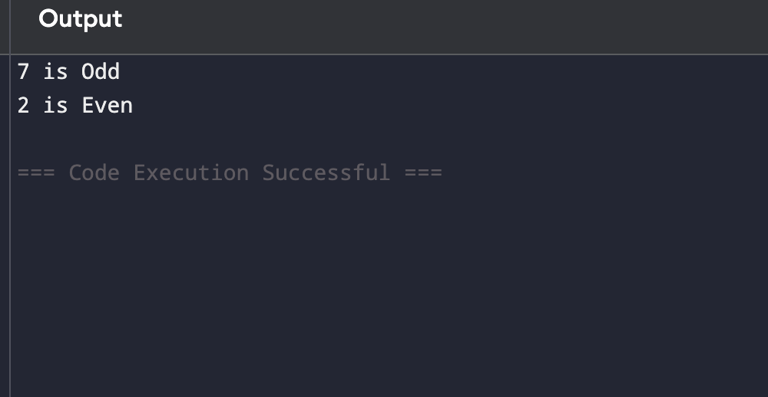

Result:
Thus finding the Even or odd is shown sucssesfull.

Task 2:
Aim:
To access and print the element present at a given index in an array.
Algorithm:
- Start
2 ) Read the size of the array n
3 ) Read n elements into the array
4) Read the index value index
5 ) Check whether index is valid
• If index ≥0 and index < n, print the element at that index
• Else, print an error message (invalid index)
- Stop
Program:
import java.util.Scanner;
public class Main {
public static void main(String[] args) {
int[] numbers = {20, 40, 30, 90, 100};
Scanner sc = new Scanner(System.in);
System.out.print("Enter index: ");
int index = sc.nextInt();
System.out.println("Element at index " + index + " is: " + numbers[index]);
sc.close();
}
}

Output:

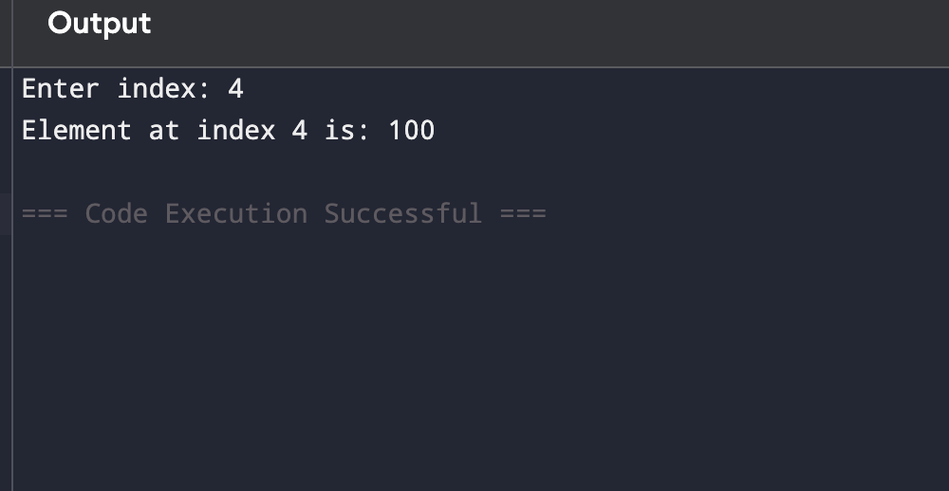
Result: Thus finding the element at index was shown sucessfully

Task 3:
Aim:
To search for a given element in a sorted array using Binary Search technique.
Algorithm:
1 )Start
2 ) Read the number of elements n
3 ) Read the n elements of the sorted array
4 ) Read the element to be searched key
5 ) Initialize low = 0 and high = n −1
6) Repeat while low ≤high
1. Calculate mid = (low + high) / 2
2. If array[mid] == key, print the position and stop
3. If key < array[mid], set high = mid −1
4. Else, set low = mid + 1
7 ) If the element is not found, print “Element not found”
8 ) Stop
Program:

import java.util.Scanner;
public class Main {
public static void main(String[] args) {

int[] arr = {2, 4, 6, 8, 10, 12, 14};

Scanner sc = new Scanner(System.in);

System.out.print("Enter element to search: ");
int target = sc.nextInt();

int left = 0;
int right = arr.length - 1;

while (left <= right) {
int mid = (left + right) / 2;

if (arr[mid] == target) {
System.out.println("Element found at index: " + mid);
return;
}

if (arr[mid] < target)
left = mid + 1;

else
right = mid - 1;
}

System.out.println("Element not found");

sc.close();
}
}

Output:

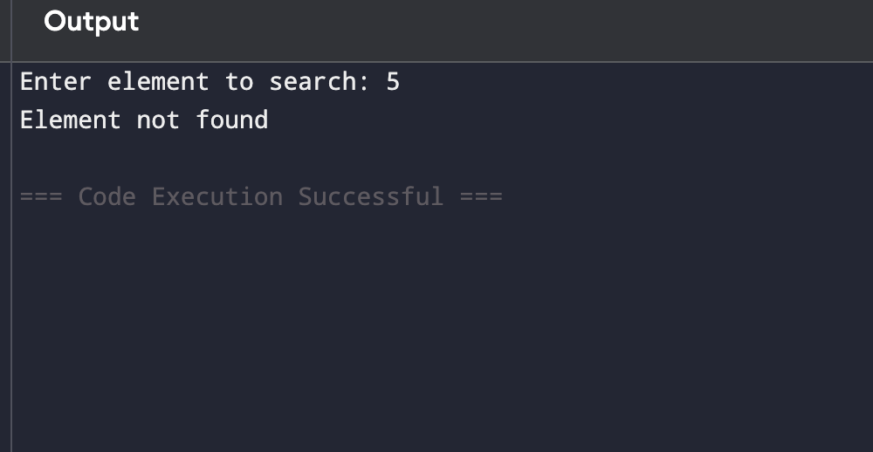
Result: Thus finding the element in sorted array using binary search is shown
successfully

Task 4:
Aim: To find the maximum element in an array of n integers.
Algorithm:
1 )Start
2 )Read the number of elements n
3 )Read n integers into the array
4 )Assume the first element of the array as maximum
• max = array[0]
5 ) Compare max with each remaining element of the array
• If any element is greater than max, update max
6 ) After completing the loop, max contains the largest element
7 ) Print the value of max
8) Stop
Program:
import java.util.Scanner;
public class Main {
public static void main(String[] args) {
Scanner sc = new Scanner(System.in);
System.out.print("Enter number of elements: ");
int n = sc.nextInt();
int[] arr = new int[n];
System.out.println("Enter " + n + " elements:");
for (int i = 0; i < n; i++) {
arr[i] = sc.nextInt();
}
int max = arr[0];
for (int i = 1; i < n; i++) {
if (arr[i] > max) {
max = arr[i];
}
}
System.out.println("Maximum element is: " + max);
sc.close();
}}

Output:
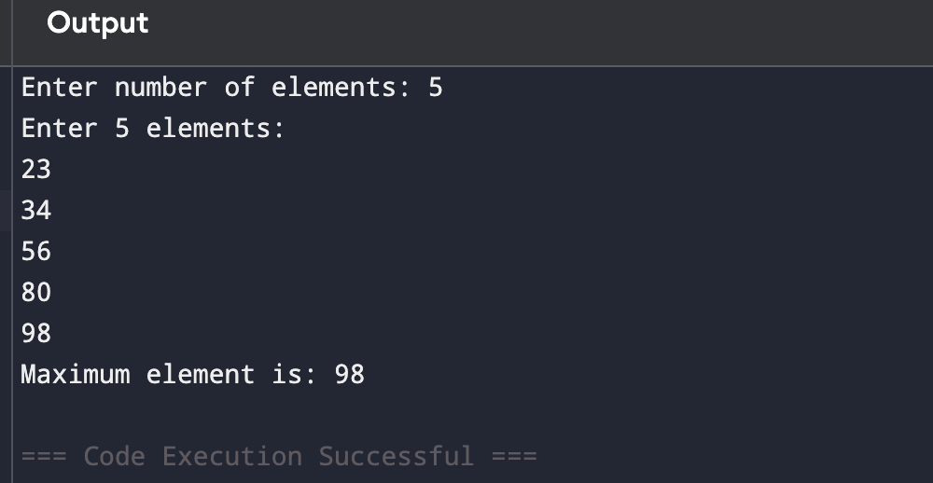
Result:Thus finding the max element was shown successfully.

Task 5:
Aim: To find the Kth smallest element in a given array of integers.
Algorithm:
1 ) Start
2 ) Read the number of elements n
3 ) Read n integers into the array
4 ) Read the positive integer k
- Sort the array in ascending order
- The element at index k −1 is the Kth smallest element
- Print the Kth smallest element
- Stop
Program:
import java.util.Arrays;
public class Main {
public static void main(String[] args) {
int[] arr = {7, 10, 4, 3, 20, 15};
int K = 4;
Arrays.sort(arr);
int kthSmallest = arr[K - 1];
int highest = arr[arr.length - 1];
System.out.println("Kth smallest element is: " + kthSmallest);
System.out.println("Highest element is: " + highest);
}
}

Output:

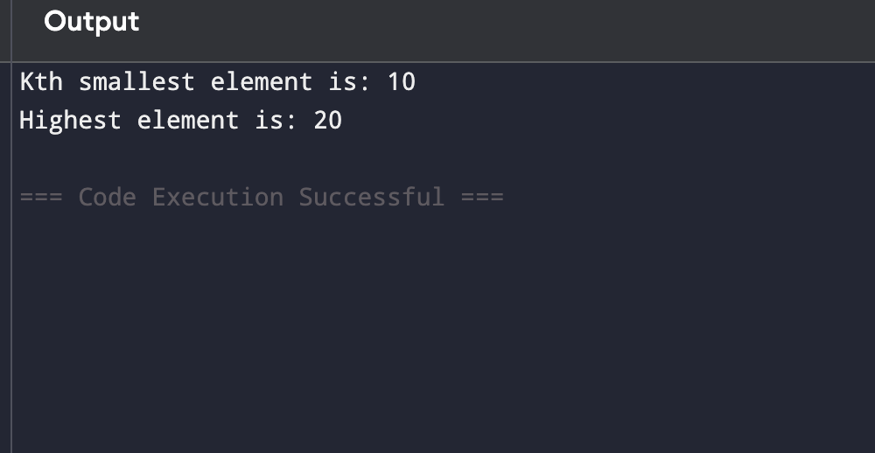
Result: Thus Finding the kth smallest element was shown successfully

Task 6:
Aim: To print all possible pairs of elements from an array of size n.
Algorithm:
1 ) Start
2 ) Read the number of elements n
3 ) Read n elements into the array
4 ) Use two nested loops to generate pairs
• Outer loop from i = 0 to n −1
• Inner loop from j = i + 1 to n −1
- Print the pair (array[i], array[j])
6 ) Repeat until all possible pairs are printed
7 ) Stop
Program:

public class Main {
public static void main(String[] args) {
int[] arr = {3,5,7,9};
for (int i = 0; i < arr.length; i++) {
for (int j = i + 1; j < arr.length; j++) {
System.out.println(arr[i] + ", " + arr[j]);
}
}
}
}

Output:

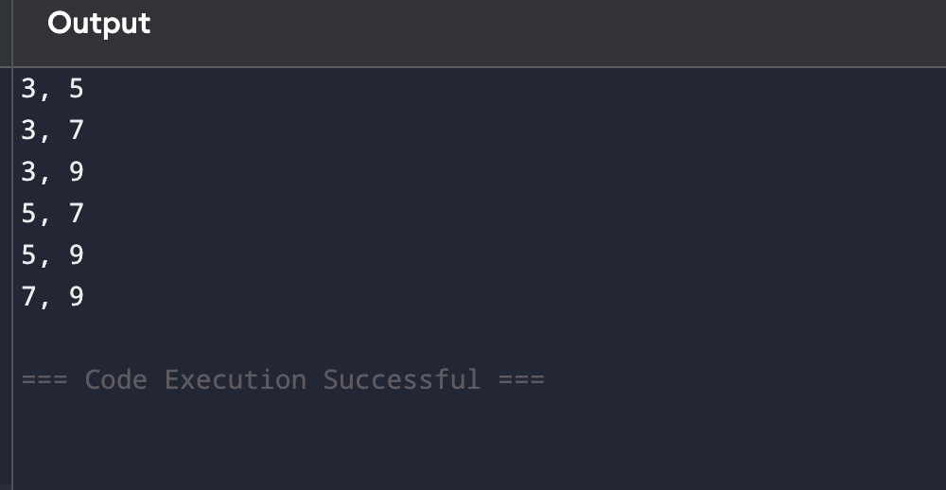
Result: Thus Finding the All pairs of elements was shown Sucessfully.

Task 7:
Aim: To find the sum of even or odd digits
Algorithm:
1) Start
2) Read integer input1 and string input2
Initialize sum = 0
While input1 > 0, repeat:
Extract the last digit:
digit = input1 % 10
3) If input2 is "even" and digit is even, then sum = sum + digit
4) Else if input2 is "odd" and digit is odd, thensum = sum + digit
5) Remove the last digit from input1:
input1 = input1 / 10
Return sum
6) End
Program:

public class UserMainCode {
public static int digitSum(int input1, String input2) {
int sum = 0;
while (input1 > 0) {
int digit = input1 % 10;
if (input2.equals("even")) {
if (digit % 2 == 0) {
sum += digit;
}
} else if (input2.equals("odd")) {
if (digit % 2 != 0) {
sum += digit;
}
}
input1 = input1 / 10;
}
return sum;
}
public static void main(String[] args) {
System.out.println(digitSum(1234, "even"));
System.out.println(digitSum(1234, "odd"));
}
}
Output:

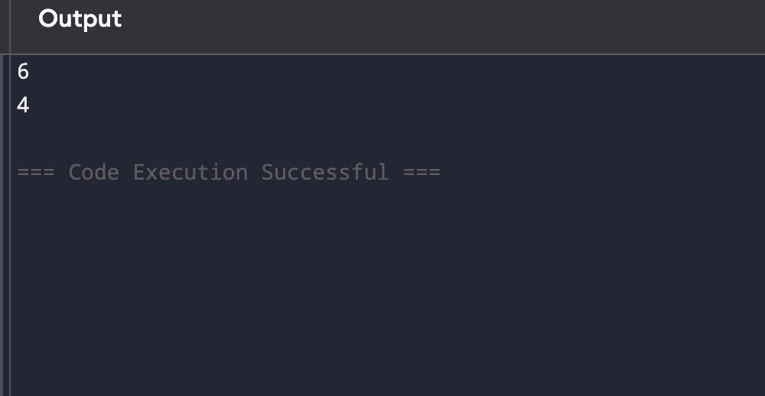

Result: Thus Finding the sum of even or odd digits was sucessfully completed.

Task 8:
Aim: To fint the Nth Fibonacci
Algorithm:
1) Start
2) Read integer n from user
3)If n == 1, print 0
4) If n == 2, print 1
5) Initialize a = 0, b = 1
Loop from 3 to n
c = a + b
a = b
b = c
6) Print c
7) Stop
Program:

import java.util.Scanner;
public class UserMainCode {
public static int nthFibonacci(int input1) {
if (input1 == 1)
return 0;
if (input1 == 2)
return 1;
int a = 0, b = 1, c = 0;
for (int i = 3; i <= input1; i++) {
c = a + b;
a = b;
b = c;
}
return c;
}
public static void main(String[] args) {
Scanner sc = new Scanner(System.in);
System.out.print("Enter n value: ");
int n = sc.nextInt();
int result = nthFibonacci(n);
System.out.println("Nth Fibonacci number: " + result);
sc.close();
}
}
}

Output:

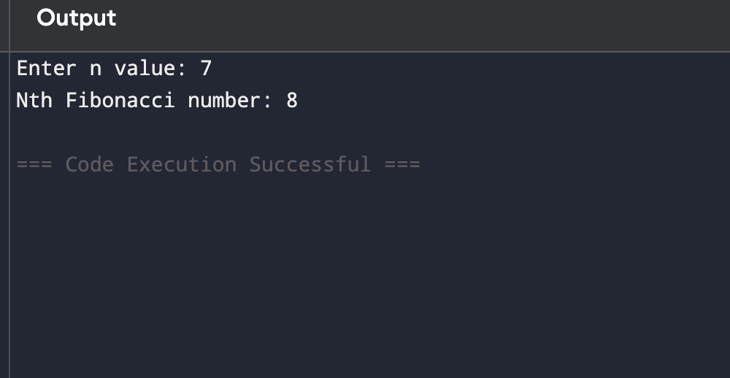

Result: Thus Finding the Nth Fibonacci was sucessfully completed.

Task 9:
Aim: TO FINT THE IS PALINDROME NUMBER ?
Algorithm:
1) Start
2) Read the number n
3) Store n in a temporary variable temp
Initialize rev = 0
Repeat while n > 0
digit = n % 10
rev = (rev * 10) + digit
n = n / 10
4) Compare rev with temp
If rev == temp, return 2 (Palindrome)
Else, return 1 (Not Palindrome)
5)Stop
Program:
import java.util.Scanner;
public class Main {
public static int isPalindrome(int input1) {
int original = input1;
int reverse = 0;
while (input1 > 0) {
int digit = input1 % 10;
reverse = reverse * 10 + digit;
input1 = input1 / 10;
}
if (original == reverse) {
return 2;
} else {
return 1;
}
}
public static void main(String[] args) {
Scanner sc = new Scanner(System.in);

System.out.print("Enter a number: ");
int num = sc.nextInt();
System.out.println(isPalindrome(num));
sc.close();
}
}
Output:

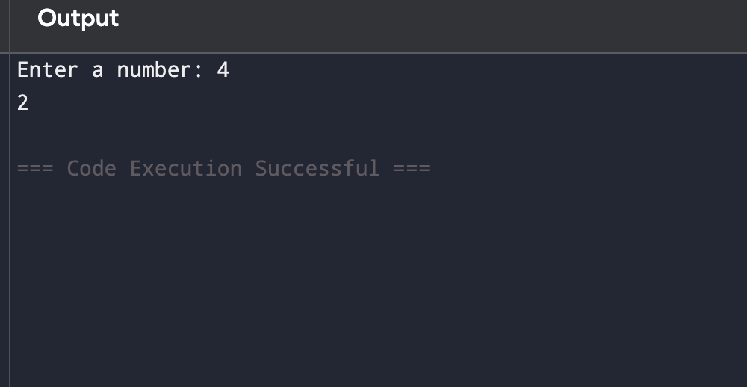

Result: Thus Finding the is Palindrome was sucessfully completed.

Task 10:
Aim: TO SUM OF LAST DIGIT OF TWO GIVEN NUMBERS
Algorithm:
1)Start
2)Read two integers a and b
3)Find last digit of each number
last1 = a % 10
last2 = b % 10
4)Calculate sum
sum = last1 + last2
5)Print / Return the sum
6)Stop

Program:

import java.util.Scanner;
public class Main {
public static void main(String[] args) {
Scanner sc = new Scanner(System.in);
System.out.print("Enter first number: ");
int a = sc.nextInt();
System.out.print("Enter second number: ");
int b = sc.nextInt();
int last1 = a % 10;
int last2 = b % 10;
int sum = last1 + last2;
System.out.println("Sum of last digits: " + sum);
sc.close();
}
}

Output:

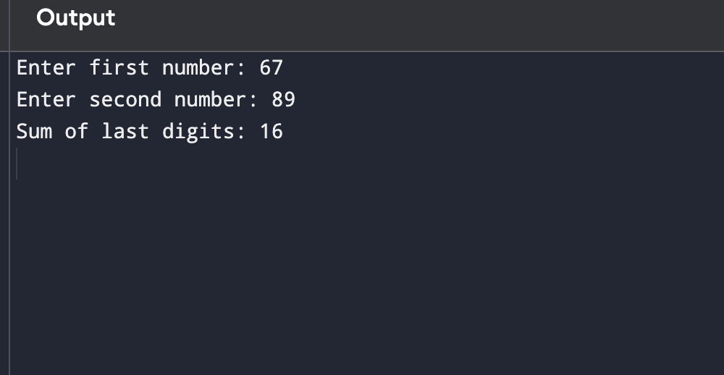

Result: Thus sum of last digit of two number was sucessfully completed.

